Phase-5 Practice Project: Assisted Practice -

2.Install Kubernetes on Cloud:

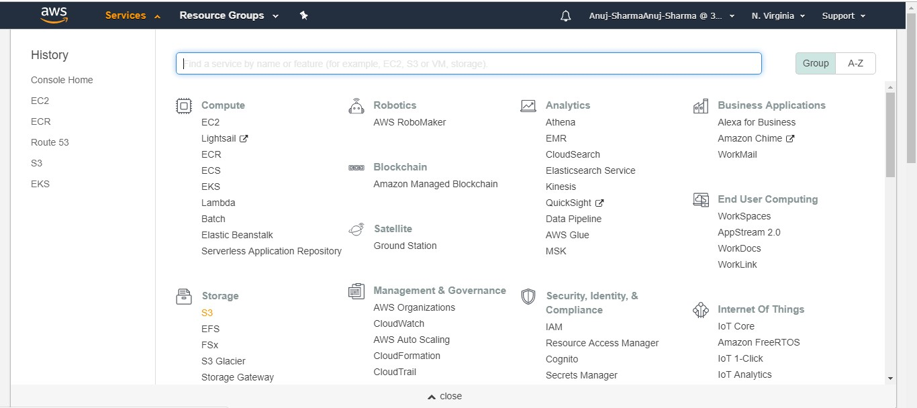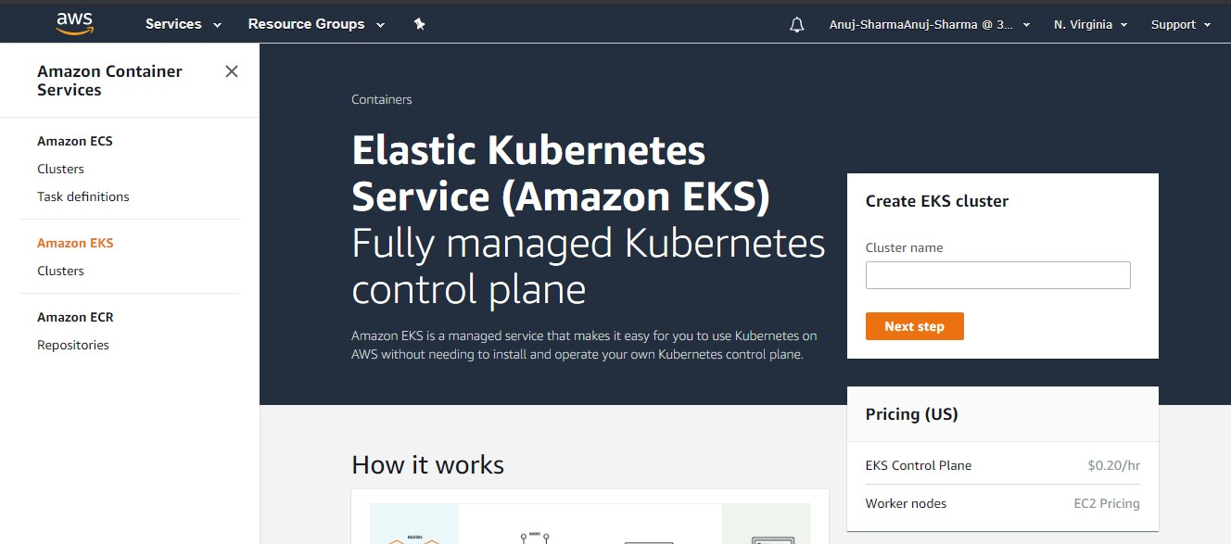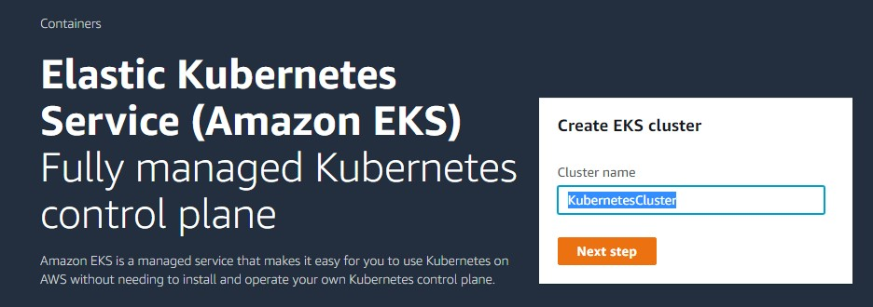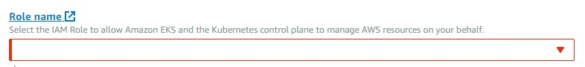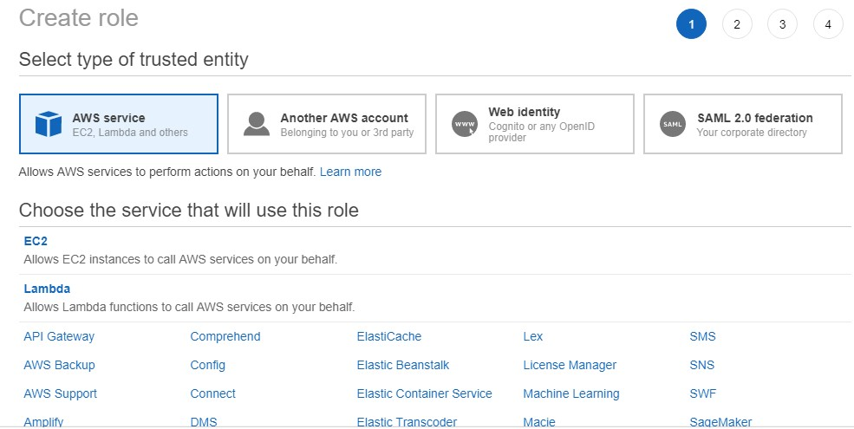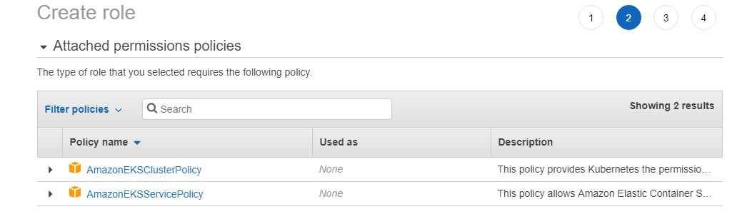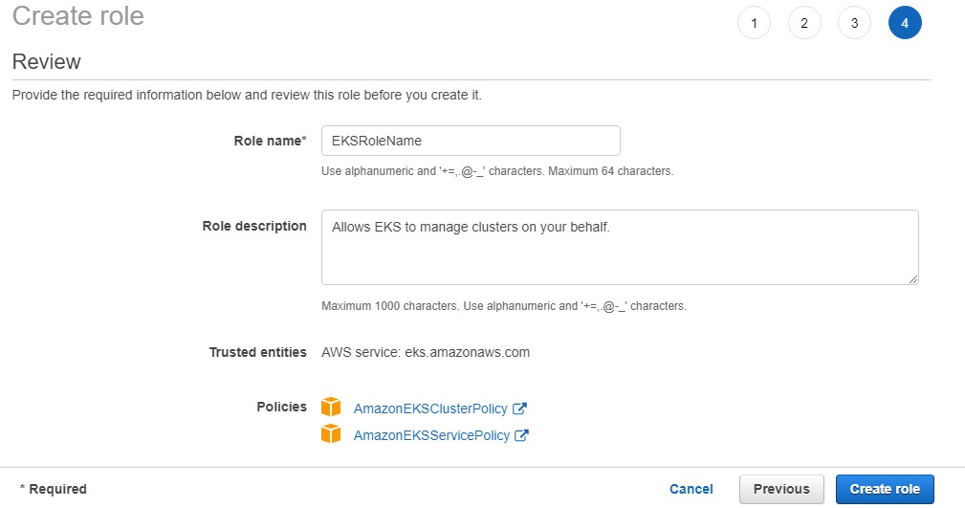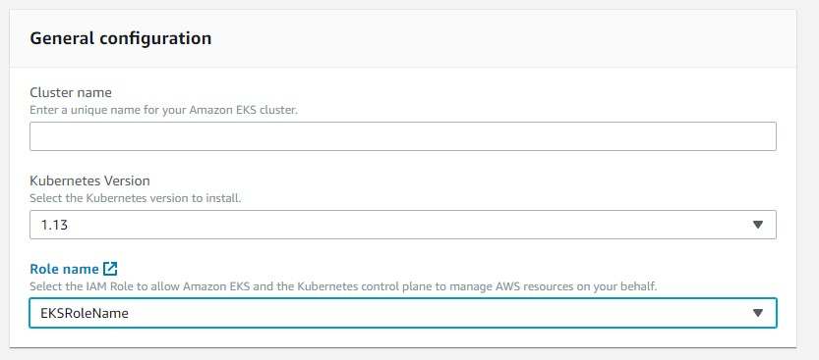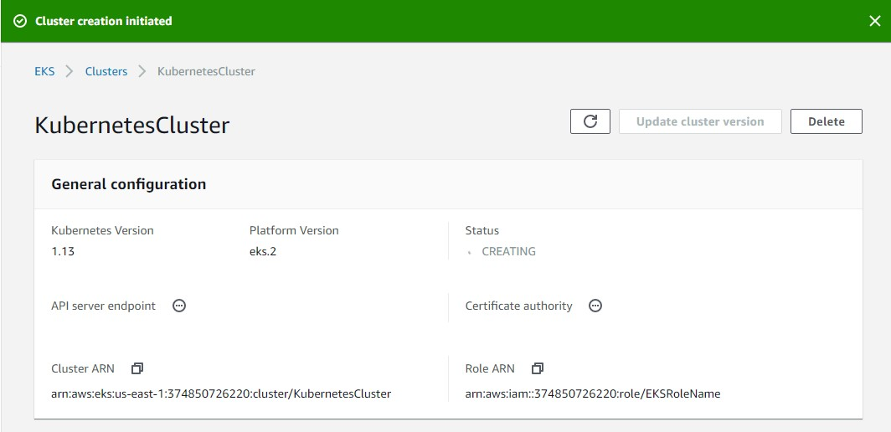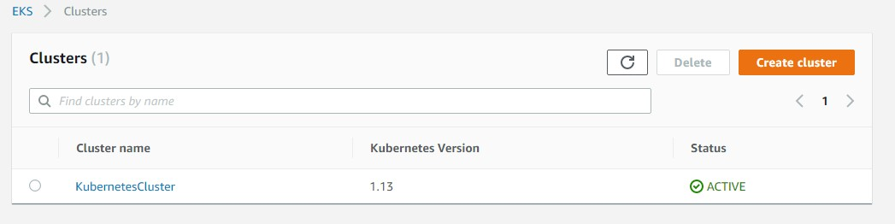

wget https://amazon-eks.s3-us-west-2.amazonaws.com/1.10.3/2018-07-

26/bin/linux/amd64/kubectl chmod +x kubectl

./kubectl

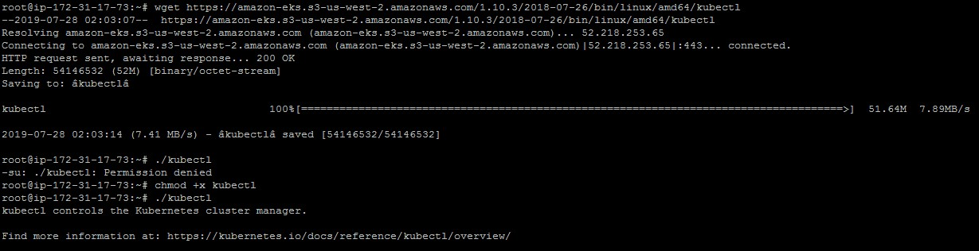

mkdir bin cp ./kubectl $HOME/bin/kubectl && export PATH=$HOME/bin:$PATH kubectl version kubectl version --short --client

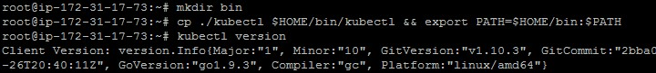

wget https://amazon-eks.s3-us-west-2.amazonaws.com/1.10.3/2018-07-

26/bin/linux/amd64/aws-iam-authenticator chmod +x ./aws-iam-authenticator

cp ./aws-iam-authenticator $HOME/bin/aws-iam-authenticator && export PATH=$HOME/bin:$PATH

aws-iam-authenticator help

